Forwarding your Parent Ignatius Email Account to a Personal Email Account

To forward your Saint Ignatius email address to your personal email:

_Pic1

1. Select the gear icon from the upper right hand corner of your inbox
2. From the drop down select See All Settings
3. Select Forwarding and POP/IMAP tab

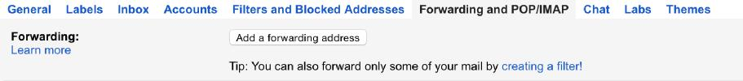

1. Click Add a forwarding address in the “Forwarding” section
2. Enter the email address to which you want to forward, a pop up will appear to confirm email address entered
3. For your security, you will receive a verification email to the email address receiving the forwarded messages
4. Open your personal email account, and open the confirmation message from Gmail
5. Click the verification link in that email
6. Go back to your Saint Ignatius parent e-mail account and enter the verification code
7. Select the Enable button next to ‘Forward a copy of incoming mail' and make sure your new forwarding address is listed in the first drop-down menu
8. Click Save Changes at the bottom of the page

NOTE: While multiple email addresses can be added as forwarding addresses,

Gmail will only redirect your email to ONE address. If you try to forward to more than one email address, it will not forward to either inbox.

Only PARENT email addresses can be forwarded to another address.

STUDENT email addresses do not have forwarding permissions.